THE SUPERIOR COLLEGE LAHORE


Faculty of Computer Science & IT

Department of Software Engineering

Final Year Project

PROJECT REPORT (Part-1)

[EDTECH GLOBAL]

Project ID: [write ID here Issued by FYP Manager]

Project Team
Student Name | Student ID | Program | Contact Number | Email Address
Usama Iqbal | Bcsm-F16-362 | BSCS | 03024017625 | Sam.iqbal000@gmail.com
Muhammad Zubair | Bcsm-F16-518 | BSCS | 03027419120 | Bcsm-F16-518@superior.edu
Hanzlah Sohaib | Bcsm-F16-524 | BSCS | 03184053915 | Bcsm-F16-524@superior.edu

[Project Supervisor]

([Designation])

Project Report: < write Project title here>

Project Report

[EDTECH GLOBAL]

Change Record

Author(s) | Version | Date | Notes | Supervisor’s Signature
 | 1.0 |  | <Original Draft>
 |  |  | <Changes Based on
 |  |  | Feedback from
 |  |  | Supervisor>
 |  |  | <Changes Based on
 |  |  | Feedback From Faculty>
 |  |  | <Added Project Plan>
 |  |  | <Changes Based on
 |  |  | Feedback from
 |  |  | Supervisor>

Faculty of CS&IT, The Superior College Lahore, Pakistan 2

Project Report: < write Project title here>

APPROVAL

PROJECT SUPERVISOR

Comments: ___________________________________________________________________

____________________________________________________________________________

_

Name:______________________________

Date:_______________________________ Signature:__________________________

PROJECT MANAGER

Comments: ___________________________________________________________________

____________________________________________________________________________

_

Date:_______________________________ Signature:__________________________

HEAD OF THE DEPARTMENT

Comments: ___________________________________________________________________

____________________________________________________________________________

_

Date:_______________________________ Signature:__________________________

Faculty of CS&IT, The Superior College Lahore, Pakistan 3

Project Report: < write Project title here>

Table of Contents

Chapter 2 |  |  | 4
Software Requirement Specifications |  |  | 4
2.1. | Introduction |  | 5
2.1.1. |  | Purpose | 5
2.1.2. |  | Document Conventions | 5
2.1.3. Intended Audience and Reading Suggestions |  |  | 5
2.1.4. |  | Product Scope | 5
2.1.5. |  | References | 6
2.2. | Overall Description |  | 6
2.2.1. |  | Product Perspective | 6
2.2.2. |  | Product Functions | 6
2.2.3. User Classes and Characteristics |  |  | 6
2.2.4. |  | Operating Environment | 7
2.2.5. Design and Implementation Constraints |  |  | 7
2.2.6. |  | User Documentation | 7
2.2.7. |  | Assumptions and Dependencies | 7
2.3. | External Interface Requirements |  | 8
2.3.1. |  | User Interfaces | 8
2.3.2. |  | Hardware Interfaces | 8
2.3.3. |  | Software Interfaces | 8
2.3.4. |  | Communications Interfaces | 9
2.4. | System Features |  | 9
2.4.1. |  | System Feature 1 | 9
2.4.1.1. |  | Description and Priority | 9
2.4.1.2. |  | Stimulus/Response Sequences | 9
2.4.1.3. |  | Functional Requirements | 9
2.4.2. |  | System Feature 2 | 10
2.4.2.1. |  | Description and Priority | 10
2.4.2.2. |  | Stimulus/Response Sequences | 10
2.4.2.3. |  | Functional Requirements | 10
2.4.3. System Feature 3 (and so on) |  |  | 11
2.5. | Other Nonfunctional Requirements |  | 11
2.5.1. |  | Performance Requirements | 11
2.5.2. |  | Safety Requirements | 11
2.5.3. |  | Security Requirements | 12

Faculty of CS&IT, The Superior College Lahore, Pakistan 4

 |  | Project Report: < write Project title here>
2.5.4. | Software Quality Attributes | 12
2.5.5. | Business Rules | 12
2.6. | Other Requirements | 12
Chapter 3 |  | 13
Use Case Analysis |  | 13
3.1. | Use Case Model | 14
3.2. |  | Fully Dressed Use Cases
 |  | 14

Faculty of CS&IT, The Superior College Lahore, Pakistan 5

Project Report: < write Project title here>

Faculty of CS&IT, The Superior College Lahore, Pakistan 6

Project Report: < write Project title here>

Chapter 2

Software Requirement Specifications

Chapter 2: Software Requirement Specifications

1.1. Introduction

1.1.1. Purpose
The current system identifies conflicts within the schedule and alerts the user to these conflicts. It does not submit this mock schedule to an advisor for approval. The schedule created on the current system must be taken to the registrar's office and the classes must be manually scheduled by hand. The only advantage currently given by the internet is the process of browsing the classes, but it does not provide an official registration. It only displays the possible options that the student can have according to the classes offered in the chosen course. As a consequence, at the end and the beginning of every single semester the registrar’s office is

Faculty of CS&IT, The Superior College Lahore, Pakistan 7

Project Report: < write Project title here>

invaded by students who need to obtain the official approval for the classes that they picked on the Internet and then transcribed manually on paper. Online and offline

1.1.2. Document Conventions

The document is made using Calibri where:

Main section are indicated with bold letters font 12 Subsections also bolded with font 12

An appendix A is added for acronyms and abbreviations

A list of figures is also included for the figures used in the document as appendix B.

1.1.3. Intended Audience and Reading Suggestions

This document is intended to be read by the customer Group This is a technical document

and the terms should be understood by the customer. The customer needs to understand

this document fully so that they can draft a design document using this SRS presented to

them by the analyst

1.1.4. Product Scope

The scope of this project includes our group of developers (Group4) assisted by our customer,

The web based registration system will be used by students whom may be familiar or not to the online registration process thus the scope of the project must be user friendly for both our customers and administrators.

This system will allow only students whom paid registration fees to register, constraints will be put on the system, like prerequisites for all courses offered. Each student will indicate two alternative choices in case a course offering becomes filled or cancelled. Once the registration process is completed for a student, the registration system sends information to the billing system so the student can be billed for the semester.
The system will have to keep a billing after the registration process has been completed. The communication and the monitoring of the application will be handled by the developers (Group4) for a smooth registration process.

Faculty of CS&IT, The Superior College Lahore, Pakistan 8

Project Report: < write Project title here>

1.1.5. References

<List any other documents or Web addresses to which this SRS refers. These may include user interface style guides, contracts, standards, system requirements specifications, use case documents, or a vision and scope document. Provide enough information so that the reader could access a copy of each reference, including title, author, version number, date, and source or location.>

1.2. Overall Description

1.2.1. Product Perspective
<Describe the context and origin of the product being specified in this SRS. For example, state whether this product is a follow-on member of a product family, a replacement for certain existing systems, or a new, self-contained product. If the SRS defines a component of a larger system, relate the requirements of the larger system to the functionality of this software and identify interfaces between the two. A simple diagram that shows the major components of the overall system, subsystem interconnections, and external interfaces can be helpful.>

1.2.2. Product Functions

<Summarize the major functions the product must perform or must let the user perform. Details will be provided in Section 3, so only a high level summary (such as a bullet list) is needed here. Organize the functions to make them understandable to any reader of the SRS. A picture of the major groups of related requirements and how they relate, such as a top level data flow diagram or object class diagram, is often effective.>

1.2.3. User Classes and Characteristics

<Identify the various user classes that you anticipate will use this product. User classes may be differentiated based on frequency of use, subset of product functions used, technical expertise, security or privilege levels, educational level, or experience. Describe the pertinent characteristics of each user class. Certain requirements may pertain only to certain user classes. Distinguish the most important user classes for this product from those who are less important to satisfy.>

Faculty of CS&IT, The Superior College Lahore, Pakistan 9

Project Report: < write Project title here>

1.2.4. Operating Environment

WEB based course registration system is an internet oriented application, it set to operate on a high available and Qos network, since registration is a sensitive thing, the quality of the network should be good for this process. Mostly a device that can access the internet and can support a huge web application for registration. Any OS can support this system as it is not particularly software or hardware dependent

1.2.5. Design and Implementation Constraints

The system is network based system, a web app that should be developed to support any web browser to be used, registration in the University is a sensitive issue an must be secure , the system design should include a lot of DB and SYSTEM validation . Courses are billed by the institution policy so this part must be secure ,so developers needs to be always there to support the delivered system in terms of validation and maintenance.

1.2.6. User Documentation

The project is available on the internet as it is a WEB based application. institute website should provide a user manual on how to use an n online registration application. Users of the system will be guided by the system all the way when registering.

1.2.7. Assumptions and Dependencies

The assumptions and dependencies relevant to the system are as follows.

All users have an a computer or any web enable device User should have internet access.
The user must have access or be on a reliable network.

Users should have been admitted to the University, and have a student number. Registration fees must be paid , or users will be blocked
Users whom are returning, must have passed prerequisites, otherwise they will be blocked.

User should read course catalogue careful in order not to make mistakes , cause they are un-reversible

Besides the user catalogue to be given, users must know which course is expected of

Faculty of CS&IT, The Superior College Lahore, Pakistan 10

Project Report: < write Project title here>

them to register.

1.3. External Interface Requirements

1.3.1. User Interfaces
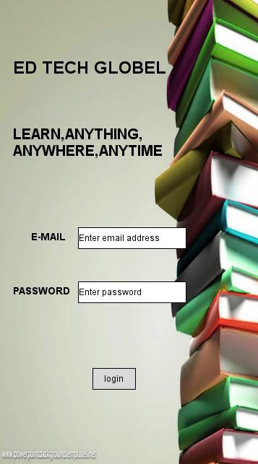

Faculty of CS&IT, The Superior College Lahore, Pakistan 11

Project Report: < write Project title here>
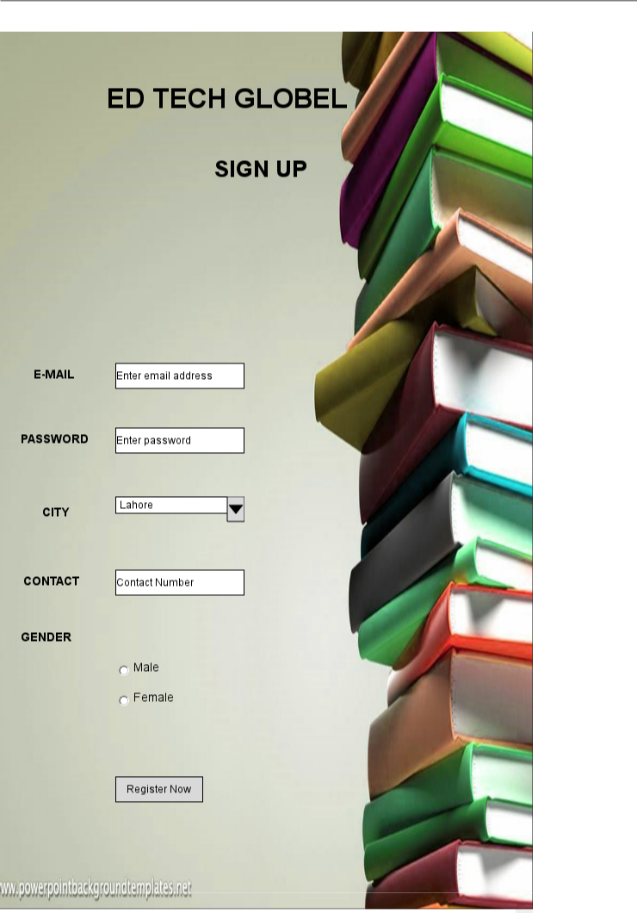

Faculty of CS&IT, The Superior College Lahore, Pakistan 12

Project Report: < write Project title here>

1.3.2. Hardware Interfaces

The system will run on different hardware gadgets. Below are the minimum hardware requirements for the smooth running of the system:

1GB RAM PC

1.8Hz processor 14” color monitor 120GB HDD CPU

Proper running internet

1.3.3. Software Interfaces

The system will require a lot of software connections so it has to be compatible to external software to be able to connect. The main system will be composed of the web portal, the operating system used and the database all communicating together and exchanging information.

Below are the different software components that the system will need to be fully operational under their respective section headings:

Databases

The following databases can be used for the system

MS access MySQL

Operating systems

The system will be compatible to the following operating systems:

Windows7,8,10 Mac OS

Tools

The following tools will be used for the system’s development:

Ajax

Notepad++ HTML 5
PHP myadmin JavaScript
CSS

Faculty of CS&IT, The Superior College Lahore, Pakistan 13

Project Report: < write Project title here>

ASP

1.3.4. Communications Interfaces

The main communication link that the system will be using is the internet. Below is the different information transferring methods and their respective protocols:

Information transmission means:

Web file transfer E-mail

Social Networks information transfer

1.4. System Features

- The online registration system comprises of two main features, namely, internet connectivity which will enables users to communicate with the server through a browser or web , and secondly the system requires database service to store the user’s data. In a nutshell this system is web application and thus is only operational in an internet enabled environment.

2.1.1. System Feature 1

<Don’t really say “System Feature 1.” State the feature name in just a few words.>

2.1.1.1. Description and Priority

<Provide a short description of the feature and indicate whether it is of High, Medium, or Low priority. You could also include specific priority component ratings, such as benefit, penalty, cost, and risk (each rated on a relative scale from a low of 1 to a high of 9).>

2.1.1.2. Stimulus/Response Sequences

<List the sequences of user actions and system responses that stimulate the behavior defined for this feature. These will correspond to the dialog elements associated with use cases.>

2.1.1.3. Functional Requirements

As to make sure a particular category of user, or potential purpose of the system, isn’t overlooked. We differentiate between functional requirements and technical

Faculty of CS&IT, The Superior College Lahore, Pakistan 14

Project Report: < write Project title here>

requirements. Functional requirements are those aspects of a system that have to do with how it is to operate or function from the perspective of someone using the system. Technical requirements, on the other hand, have more to do with how a system is to be built internally in order to meet the functional requirements. The high-level use cases for the SRS are:
  - Enroll in university.

- Register for a course.

- Drop a course.

  - Determine a student’s course load.

  - View schedule of classes.

- Request a student roster for a given course.

  - Request a transcript for a given student.

- Maintain course information: course id, course description, course instructor.

- Post final semester grades for a given course.

2.1.2. System Feature 2

<Don’t really say “System Feature 1.” State the feature name in just a few words.>

2.1.2.1. Description and Priority

<Provide a short description of the feature and indicate whether it is of High, Medium, or Low priority. You could also include specific priority component ratings, such as benefit, penalty, cost, and risk (each rated on a relative scale from a low of 1 to a high of 9).>

2.1.2.2. Stimulus/Response Sequences

<List the sequences of user actions and system responses that stimulate the behavior defined for this feature. These will correspond to the dialog elements associated with use cases.>

2.1.2.3. Functional Requirements

<Itemize the detailed functional requirements associated with this feature. These are the software capabilities that must be present in order for the user to carry out the services provided by the feature, or to execute the use case. Include how the product should respond to anticipated error conditions or invalid inputs. Requirements should be

Faculty of CS&IT, The Superior College Lahore, Pakistan 15

Project Report: < write Project title here>

concise, complete, unambiguous, verifiable, and necessary. Use “TBD” as a placeholder to indicate when necessary information is not yet available.>

<Each requirement should be uniquely identified with a sequence number or a meaningful tag of some kind.>

REQ-SF2-1:

REQ-SF2-2:

REQ-SF2-3:

2.1.3. System Feature 3 (and so on)

2.2. Other Nonfunctional Requirements

2.2.1. Performance Requirements
<If there are performance requirements for the product under various circumstances, state them here and explain their rationale, to help the developers understand the intent and make suitable design choices. Specify the timing relationships for real time systems. Make such requirements as specific as possible. You may need to state performance requirements for individual functional requirements or features.>

2.2.2. Safety Requirements

<Specify those requirements that are concerned with possible loss, damage, or harm that could result from the use of the product. Define any safeguards or actions that must be taken, as well as actions that must be prevented. Refer to any external policies or regulations that state safety issues that affect the product’s design or use. Define any safety certifications that must be satisfied.>

2.2.3. Security Requirements

Faculty of CS&IT, The Superior College Lahore, Pakistan 16

Project Report: < write Project title here>

<Specify any requirements regarding security or privacy issues surrounding use of the product or protection of the data used or created by the product. Define any user identity authentication requirements. Refer to any external policies or regulations containing security issues that affect the product. Define any security or privacy certifications that must be satisfied.>

2.2.4. Software Quality Attributes

<Specify any additional quality characteristics for the product that will be important to either the customers or the developers. Some to consider are: adaptability, availability, correctness, flexibility, interoperability, maintainability, portability, reliability, reusability, robustness, testability, and usability. Write these to be specific, quantitative, and verifiable when possible. At the least, clarify the relative preferences for various attributes, such as ease of use over ease of learning.>

2.2.5. Business Rules

<List any operating principles about the product, such as which individuals or roles can perform which functions under specific circumstances. These are not functional requirements in themselves, but they may imply certain functional requirements to enforce the rules.>

2.3. Other Requirements

<Define any other requirements not covered elsewhere in the SRS. This might include database requirements, internationalization requirements, legal requirements, reuse objectives for the project, and so on. Add any new sections that are pertinent to the project.>

Faculty of CS&IT, The Superior College Lahore, Pakistan 17

Project Report: < write Project title here>

Chapter 3

Use Case Analysis

Chapter 3: System Analysis

E-learning system is a Web-based system for training programs and information sharing between individuals giving them the flexibility to access it from their workplace or home.

Faculty of CS&IT, The Superior College Lahore, Pakistan 18

Project Report: < write Project title here>

Authorized individuals have 24/7 access to this unique system through URL or through a unique User ID and Password. The E-learning system goes far beyond conventional training by sharing every idea, managing individual training requirements and reporting training progress. Most E-learning platform s are Web-based and facilitate “anytime, anyplace, any pace” access to learning content and administration. E-learning platforms enable an organization to effectively train a large group of students spread across the organization. With a Learning Platform, training and e-Learning are managed by software that allows users and administrators alike to easily access tests and assignments reports.

3.1. Use Case Model

Faculty of CS&IT, The Superior College Lahore, Pakistan 19

Project Report: < write Project title here>
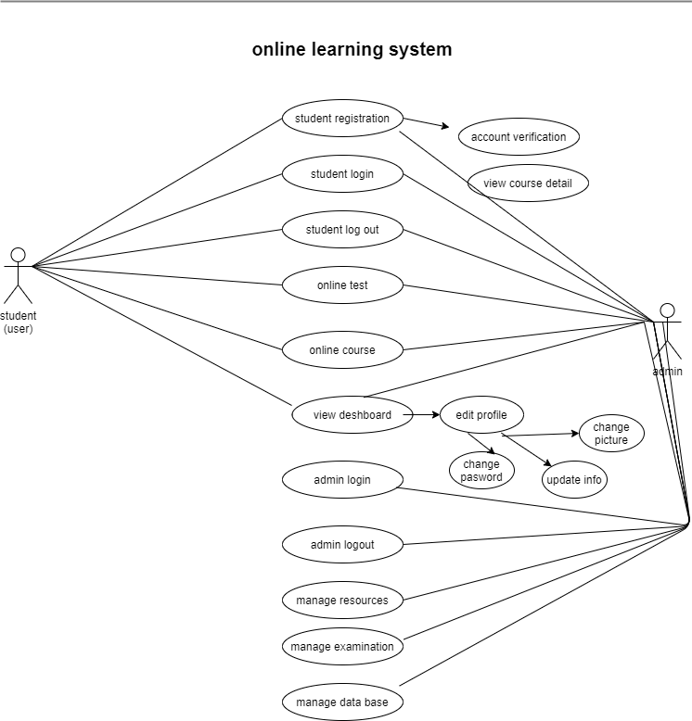

Student and teacher

Faculty of CS&IT, The Superior College Lahore, Pakistan 20

Project Report: < write Project title here>
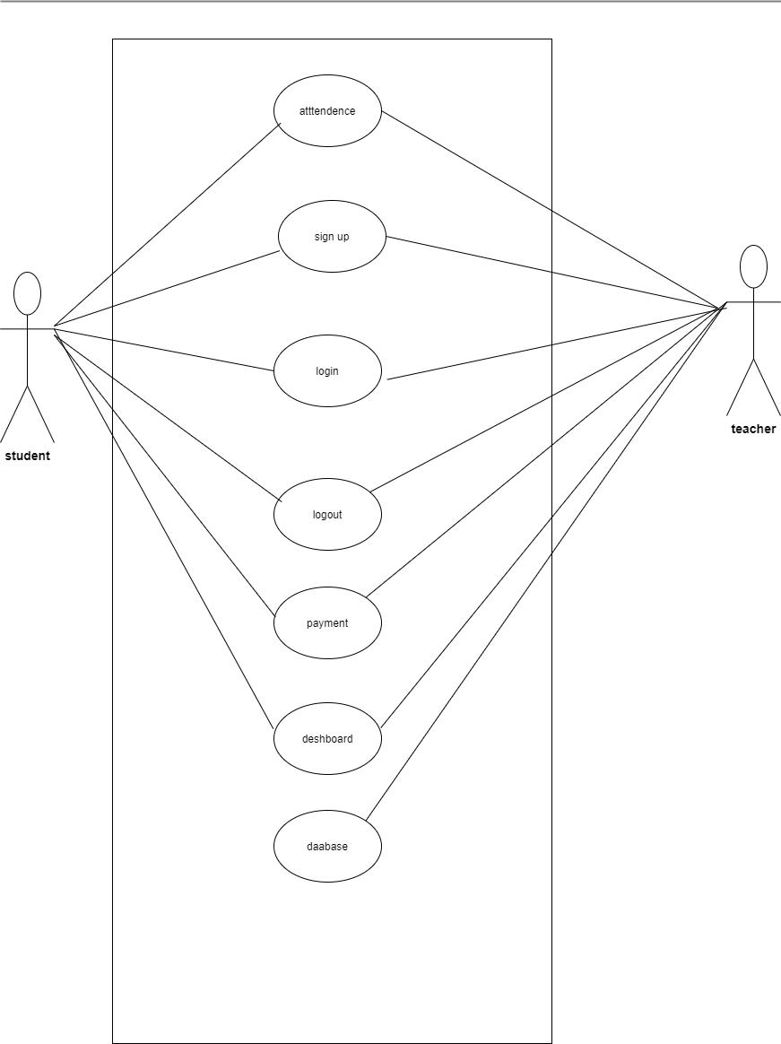

Faculty of CS&IT, The Superior College Lahore, Pakistan 21

Project Report: < write Project title here>

3.2. Fully Dressed Use Cases

Primary Actor:

Student, Admin, Insructor

Stakeholders and Interests:

Student:

wants to enrol for a course and for no eligibility problems to later arise,wants proof of enrolment, wants the process to be clear and simple.

School Office Staff:

wants only eligible students to enrol for courses, wantaccurate records of which students are enrolled on which courses, want to knowhow many students are registered to each course.

Lecturer:

wants accurate lists of students enrolled for the courses he or she willteach.

Preconditions:

Student is identified and authenticated by system.

Success Guarantee (Postconditions):

!

Student is aware of enrolment on chosen course. List of students enrolled tocourse is updated. Student has proof of enrolment.
Main Success Scenario:

The user requests a list of courses currently available for enrolment.

1: Noc o u r s e s a v a i l a b l e

2. The system retrieves the list of courses available and displays the list to the user

.3. The system provides the user with the opportunity to select a course or to exit theuse case

Faculty of CS&IT, The Superior College Lahore, Pakistan 22

Project Report: < write Project title here>

Use Case Ends

.4. The user selects a course for which he or she wants to enrol.

The system retrieves the details for the chosen course, including the course outline,timetable and eligibility requirements and displays the details to the user .5. The user confirms that he or she wants to enrol for the course.
- The system checks that the user has taken and passed the pre-requisite courses forthe chosen course User is not eligible to enrol due to missing pre-requisites
- The system checks that the user is not already enrolled on a course whosetimetable clashes with the chosen course.
- User is not eligible to enrol due totimetable clashes

Faculty of CS&IT, The Superior College Lahore, Pakistan 23

